Hanoi University of Science and technology

**ELECTROIC AND TELECOMUNICATION SCHOOL**

----- 🙡 🕮 🙣 -----



**Graduation thesis**

***Topic:* Scene text detection and recognition using CRAFT and 4-stage network**

Instructor: TS. Tran Thi Thanh Hai

Nhóm sinh viên thực hiện:

|  |  |  |
| --- | --- | --- |
| Number | Name | Student ID |
| 1 | Đỗ Trung Kiên | 20182922 |

**Ha Noi, 6-2022**

MỤC LỤC

Chapter I : Introduction 4

Problem 4

Challenge 4

Motivation 5

Chapter II. Theory background 6

**I.1. OCR theory background** 6

**I.1.1. OCR and applications** 6

**I.1.2. OCR related concepts** 7

**I.2. Scene text detection theory background** 8

**I.2.1. Scene text detection overview** 8

**I.2.2. CRAFT Training technique** 12

**I.3. Scene text recognition theory background** 15

**I.3.1. Scene text recognition overview** 15

**I.3.2. Dataset** 15

**I.3.3. Training techniques** 20

Chapter III. Implement 23

**II.1. CRAFT** 23

**II.1.1. Training CRAFT** 23

**II.1.3 Testing CRAFT** 25

**II.2. 4-Stage Network** 26

**II.2.1. Training 4-Stage Network** 26

**II.2.2. Evaluate 4-Stage Network** 27

**II.2.3. Testing 4-Stage Network** 28

Chapter IV : Web design 30

Conclusion 32

Future Work 33

References 34

Danh sách hình vẽ

MỤC LỤC 2

MỞ ĐẦU 3

CHƯƠNG I. TÊN CHƯƠNG 4

**I.1. Tên đầu mục cấp 1** 4

**I.1.1. Tên đầu mục cấp 2** 4

**I.1.2. Tên đầu mục cấp 2** 4

**I.2. Tên đầu mục cấp 1** 4

**I.2.1. Tên đầu mục cấp 2** 4

**I.2.2. Tên đầu mục cấp 2** 4

**I.2.3. Tên đầu mục cấp 2** 4

CHƯƠNG II. TÊN CHƯƠNG 5

**II.1. Tên đầu mục cấp 1** 5

**II.1.1. Tên đầu mục cấp 2** 5

**II.1.2. Tên đầu mục cấp 2** 5

**II.2. Tên đầu mục cấp 1** 5

**II.2.1. Tên đầu mục cấp 2** 5

**II.2.2. Tên đầu mục cấp 2** 5

**II.2.3. Tên đầu mục cấp 2** 5

KẾT LUẬN 6

TÀI LIỆU THAM KHẢO 7

# **Chapter I : Introduction**

## Problem

The pandemic has locked us in our homes for quite a few months now.  
But remember, when life was normal, we’d go shopping, hang out with our friends, watch movies and have great food at malls maybe in another country far from us.

What do you do when you read text off a banner? Your eyes first detect the presence of text, figure out where each character is, and then you recognize the characters. That’s exactly what a DL Model needs to do as well!

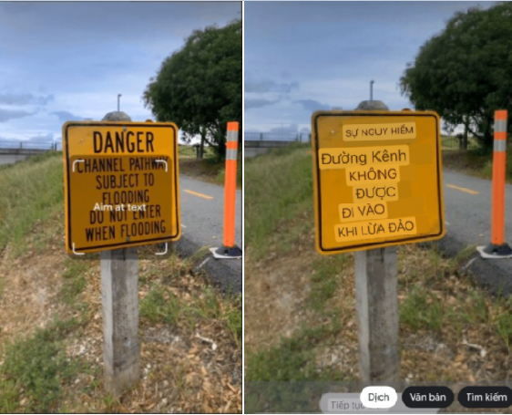

Figure:

## Challenge

Also, do you remember how each store had a unique fancy way of writing its name? Popular brands like Gucci, Sears, Pantaloons, and Lifestyle use curvy or round fonts in their logos. While all of this attracts customers, it sure poses a challenge to Deep Learning (DL) models performing text detection and recognition.

You want to build an app that have a lot of features and real-world applications of text detection features. It is benefits with millions of people today.

While there are many complex pipelines involved in building a solution you will meet, one of the key components is to detect text in natural scenes and it should be very accurate irrespective of complex image backgrounds, mixed/varying text colors, text orientation, graphics, geometrical distortions.

## Motivation

Ever wondered how can create an app is able to understand the text in natural scenes and provide solutions like

* Real-time translation: really helpful when you’re traveling abroad
* Adding calendar events by capturing billboards, or invitations
* Copy-Paste text from images, etc...

Lately, OCR has become a hot topic in deep learning wherein each new architecture is trying its best to outperform the others.

Popular deep-learning-based OCR module, Tesseract works wonders on structured text like documents but falters on curvy, irregular shaped text in fancy fonts.

This leads us to build accurate and powerful deep learning models for Scene Text Detection or Text Detection in the Wild.

Luckily, we have these amazing networks by Clova AI which outperform Tesseract in diverse text appearances that occur in the real world. In this report, I will research and build model to detection and recognition scene text.

# **Chapter II. Theory background**

## **I.1. OCR theory background**

### **I.1.1. OCR and applications**

In this era of digitization, the need for the extraction of textual information from different sources has risen to a large extent. Fortunately, recent advances in Computer Vision allow us to make great strides in easing the burden of text detection and other document analysis and understanding. In Computer Vision the method of converting the text present in images or scanned documents to a machine-readable format that can later be edited, searched, and can be used for further processing is known as Optical Character Recognition (OCR).

Applications of OCR

a. Information Retrieval and Automatic Data Entry- OCR plays a very important role for many companies and institutions which have thousands of documents to process, analyze, and transform to carry out day-to-day operations.

For Example- In bank information like account details, the amount from the cheque can easily be extracted using OCR. Similarly, at airports, while the passport checking the information can also be extracted using OCR. Other examples are information retrieval using OCR from receipts, invoices, forms, statements, contracts etc.

b. Vehicle Number Plate Recognition- OCR can also be used to recognise the vehicle registration plate which can then be used for vehicle tracking, toll collection, etc.

c. Self Driving Car- OCR can also be used to build models for self-driving cars. It can help to recognize the traffic signs. Without this, the self-driving car will pose a risk for both pedestrians and other vehicles on road.

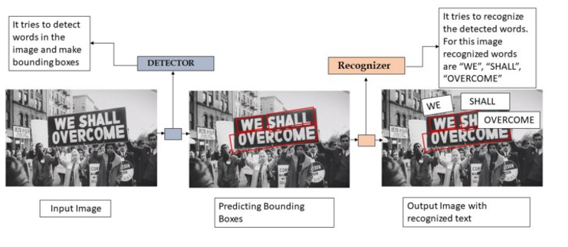

Figure:

So, In our case, we are using any natural image or scene and for a given image/scene we want to localize char/word/sentence in the image by bounding box. After that, we want to recognize the localized texts which can be of any language.

### **I.1.2. OCR related concepts**

**Text Detection** is the process of predicting and localizing the text instances from the image. While there are many traditional image processing approaches to perform text detection, deep learning models tend to out-perform them in all easy to very complex real-world scenarios.

The process of localizing text using deep learning can be achieved in two different ways, Object Detection, and Image Segmentation. Both have their own positives and complexities in terms of creating datasets, model training, and inference options.

**Objection Detection** is a technique to localize objects in the image with bounding boxes as shown in the below image, but will not give any information about the shape of the object, as they are either rectangular or square in shape.



Labeling the images for Object detection is quite simple compared to segmentation.

**Segmentation** is a technique of classifying each pixel of the image to one of the available classes, in our case it’ll be text vs non-text pixels. However, For Character Recognition, the annotations will differ, each pixel will be classified as one of the available characters.

## **I.2. Scene text detection theory background**

### **I.2.1. Scene text detection overview**

**Scene Text Detection** is a task to detect text regions in the complex background and label them with bounding boxes.

Scene text detection has attracted much attention in the computer vision field because of its numerous applications, such as instant translation, image retrieval, scene parsing, geo-location, and blind-navigation. Recently, scene text detectors based on deep learning have shown promising performance These methods mainly train their networks to localize wordlevel bounding boxes. However, they may suffer in difficult cases, such as texts that are curved, deformed, or extremely long, which are hard to detect with a single bounding box.

The main objective of **CRAFT: Character-Region Awareness For Text detection**is to localize the individual character regions and link the detected characters to a text instance.

CRAFT adopts a fully convolutional network architecture based on VGG-16 as its backbone. In simple words, VGG16 is essentially the feature extracting architecture that is used to encode the network’s input into a certain feature representation. The decoding segment of the CRAFT network is similar to UNet. It has skip connections that aggregate low-level features.

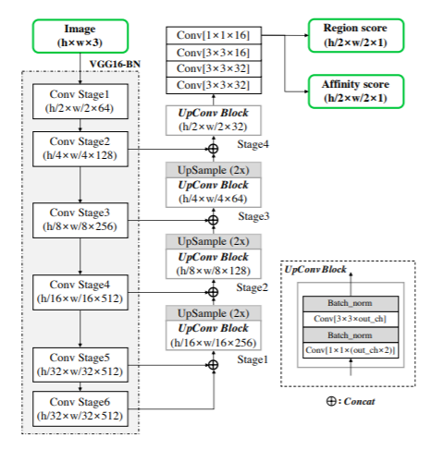

Figure1: CRAFT architecture

CRAFT predicts two scores for each character:

* **Region Score:** As the name suggests, it gives the region of the character. It localizes the character.
* **Affinity Score:** ‘Affinity’ is the degree to which a substance tends to combine with another. So, an affinity score merges characters into a single instance (a word).

Unlike a binary segmentation map, which labels each pixel discretely, CRAFT encode the probability of the character center with a Gaussian heatmap. This heatmap representation has been used in other applications, such as in pose estimation works due to its high flexibility when dealing with ground truth regions that are not rigidly bounded. CRAFT use the heatmap representation to learn both the region score and the affinity score.

This figure summarizes the label generation pipeline for a synthetic image. Computing the Gaussian distribution value directly for each pixel within the bounding box is very timeconsuming

The pseudo-ground truths (pseudoGTs) for the region score and the affinity score can be generated by the steps described in fig using the obtained quadrilateral character-level bounding boxes.

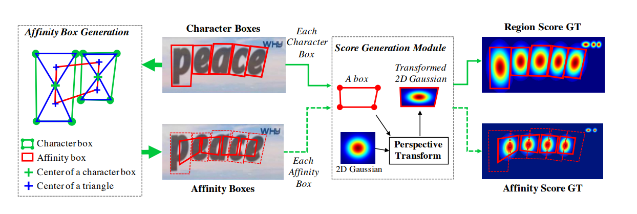

Figure 2:

Step 1: Prepare a 2-dimensional isotropic Gaussian map. By drawing diagonal lines to connect opposite corners of each character box, we can generate two triangles –which we will refer to as the upper and lower character triangles.

Step 2: Compute perspective transform between the Gaussian map region and each character box

Step 3: Warp Gaussian map to the box area. The affinity boxes are defined using adjacent character boxes. Then, for each adjacent character box pair, an affinity box is generated by setting the centers of the upper and lower triangles as corners of the box.

The proposed ground truth definition enables the model to detect large or long-length text instances sufficiently, despite using small receptive fields. On the other hand, previous approaches like box regression require a large receptive field in such cases. Our character-level detection makes it possible for convolutional filters to focus only on intracharacter and inter-character, instead of the entire text instance

CRAFT generates two maps as output: Region Level Map and Affinity Map.

The areas where the characters are present are marked in the Region Map:

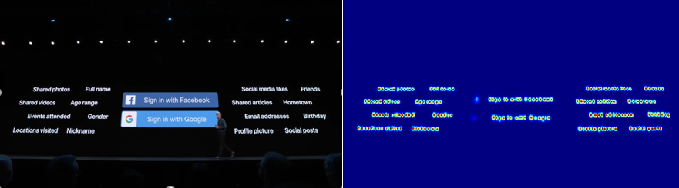

Figure:

The Affinity Map is a pictorially represents the related character. Red symbolizes the characters have a high affinity and must be merged into a word:

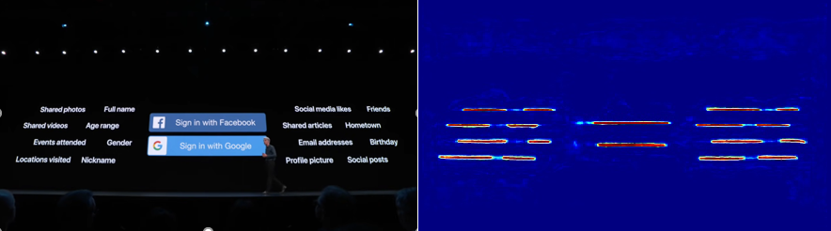Figure:

Finally, the affinity and region scores are combined to give the bounding box of each word. The coordinates are in the order:  
(left-top), (right-top) (right-bottom), (left-bottom), where each coordinate is an (x, y) pair.

**I.2.2. CRAF related concept**

With the introduction of a wide range of pre-trained models trained on humongous data, the success of Machine learning in industrial applications has grown exponentially. While we can easily utilize these models by transfer learning either as feature extractors or by fine-tuning on our specific dataset, but generally the performance isn’t great if the pattern is significantly different from the data on which these models are originally trained.

Especially in the case of Natural Language Processing, there are many patterns specific to the data which often reduces the applicability of pre-trained models. At the same time, the challenges involved in getting application-specific annotations not only reduces the usability of the data but also of supervised (transfer) learning for modeling.

Since unannotated text data is generally available in abundance, unsupervised/ weakly supervised approaches become the first-hand choice for data exploration and even for modeling. Because building a team of annotators with the domain expertise is not only expensive but also time-consuming, recently, practitioners have been turning to the weaker forms of supervision which is the main focus of CRAFT.

**Weak supervision** is a branch of machine learning where noisy, limited, or imprecise sources are used to provide supervision signal for labeling large amounts of training data in a supervised learning setting. This approach alleviates the burden of obtaining hand-labeled data sets, which can be costly or impractical. Instead, inexpensive weak labels are employed with the understanding that they are imperfect, but can nonetheless be used to create a strong predictive model.

### **I.2.2. CRAFT Training technique**

Unlike synthetic datasets, real images in a dataset usually have word-level annotations. Here, we generate character boxes from each word-level annotation in a weakly-supervised manner, as summarized in figure below

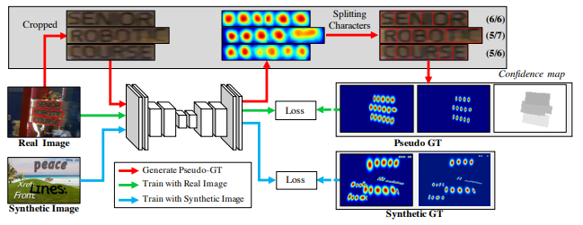

Figure: Real and synthetic images in a weakly-supervised Learning

When a real image with word-level annotations is provided, the learned interim model predicts the character region score of the cropped word images to generate character-level bounding boxes. In order to reflect the reliability of the interim model’s prediction, the value of the confidence map over each word box is computed proportional to the number of the detected characters divided by the number of the ground truth characters, which is used for the learning weight during training.

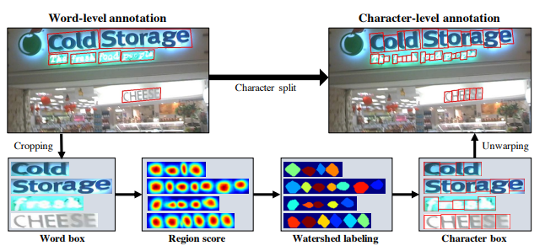

Figure: Character split procedure for achieving character-level annotation

First, the word-level images are cropped from the original image.

Second, the model trained up to date predicts the region score.

Third, the watershed algorithm is used to split the character regions, which is used to make the character bounding boxes covering regions.

Finally, the coordinates of the character boxes are transformed back into the original image coordinates using the inverse transform from the cropping step.

When the model is trained using weak-supervision, we are compelled to train with incomplete pseudo-GTs. If the model is trained with inaccurate region scores, the output might be blurred within character regions. To prevent this, we measure the quality of each pseudo-GTs generated by the model. Fortunately, there is a very strong cue in the text annotation, which is the word length. In most datasets, the transcription of words is provided and the length of the words can be used to evaluate the confidence of the pseudoGTs.

For a word-level annotated sample *w* of the training data, let *R(w)* and *l(w)* be the bounding box region and the word length of the sample *w*, respectively. Through the character splitting process, we can obtain the estimated character bounding boxes and their corresponding length of characters *lc(w).* Then the confidence score sconf (*w*) for the sample *w* is computed as:

$$s_{conf}(w)=\frac{l(w)-min(l(w),|l(w)-l^{c}(w)|)}{l(w)}$$

If the confidence score *sconf (w)* is below 0.5, the estimated character bounding boxes should be neglected since

they have adverse effects when training the model. In this

case, we assume the width of the individual character is constant and compute the character-level predictions by simply

dividing the word region *R(w)* by the number of characters

l(w). Then, *sconf (w)* is set to 0.5 to learn unseen appearances of texts.

and the pixel-wise confidence map Sc for an image is computed as:

$$S_{c}(p)=\left\{\begin{aligned}s_{conf}(w) p ∈R(w) \\ 1 otherwise\end{aligned}\right.$$

where p denotes the pixel in the region R(w). The objective L is defined as:

$$L=\sum_{p}{S_{c}(p)}.(||S_{r}(p)-{S_{r}}^{*}(p)|{|_{2}}^{2}+||S_{a}(p)-{S_{a}}^{*}(p)|{|_{2}}^{2})$$

where Sr*(p) and Sa*(p) denote the pseudo-ground truth region score and affinity map, respectively, and Sr(p) and Sa(p) denote the predicted region score and affinity score, respectively. When training with synthetic data, we can obtain the real ground truth, so Sc(p) is set to 1.

As training is performed, the CRAFT model can predict characters more accurately, and the confidence scores *sconf (w)* are gradually increased as well. Figure below shows the character region score map during training. At the early stages of training, the region scores are relatively low for unfamiliar text in natural images. The model learns the appearances of new texts, such as irregular fonts, and synthesized texts that have a different data distribution against that of the SynthText dataset.

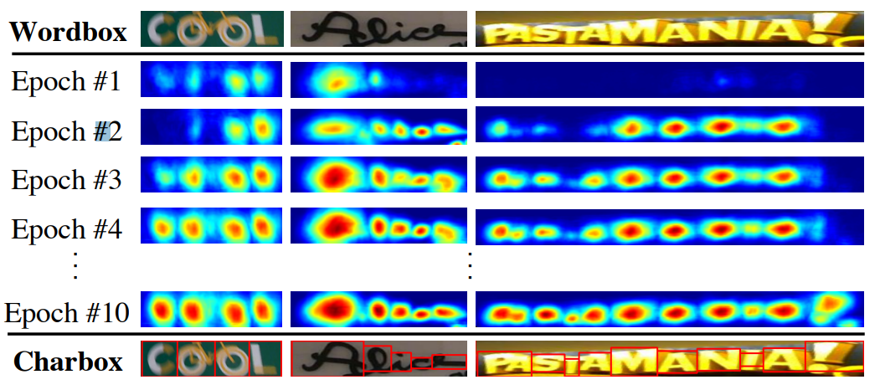

Figure:

At the inference stage, the final output can be delivered in various shapes, such as word boxes or character boxes, and further polygons. For datasets like ICDAR, the evaluation protocol is word-level intersection-over-union (IoU), so here we describe how to make word-level bounding boxes QuadBox from the predicted Sr and Sa through a simple yet effective post-processing step. 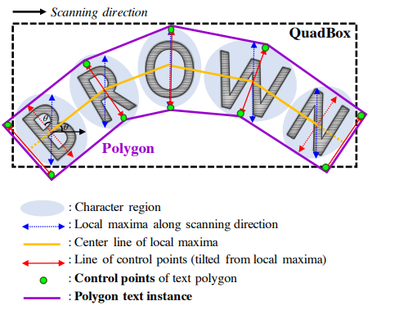

The post-processing for finding bounding boxes is summarized as follows. First, the binary map M covering the image is initialized with 0. M(p) is set to 1 if Sr(p) > τr or Sa(p) > τa, where τr is the region threshold and τa is the affinity threshold. Second, Connected Component Labeling (CCL) on M is performed. Lastly, QuadBox is obtained by finding a rotated rectangle with the minimum area enclosing the connected components corresponding to each of the labels. The functions like connectedComponents and minAreaRect provided by OpenCV can be applied for this purpose.

Additionally, we can generate a polygon around the entire character region to deal with curved texts effectively. The procedure of polygon generation is illustrated in Fig. 7. The first step is to find the local maxima line of character regions along the scanning direction, as shown in the figure with arrows in blue. The lengths of the local maxima lines are equally set as the maximum length among them to prevent the final polygon result from becoming uneven. The line connecting all the center points of the local maxima is called the center line, shown in yellow. Then, the local maxima lines are rotated to be perpendicular to the center line to reflect the tilt angle of characters, as expressed by the red arrows. The endpoints of the local maxima lines are the candidates for the control points of the text polygon. To fully cover the text region, we move the two outer-most tilted local maxima lines outward along the local maxima center line, making the final control points (green dots).

## **I.3. Scene text recognition theory background**

### **I.3.1. Scene text recognition overview**

In text recognition, the text is assumed to be already detected and located and the rectangular bounding box containing the text is available. The word present in the bounding box needs to be recognized. The methods available to perform word recognition can be broadly classified into top-down and bottom-up approaches.

In the top-down approaches, a set of words from a dictionary is used to identify which word suits the given image.Images are not segmented in most of these methods. Hence, the top-down approach is sometimes referred as segmentation free recognition.

In the bottom-up approaches, the image is segmented into multiple components and the segmented image is passed through a recognition engine. Either an off the shelf Optical character recognition (OCR) engine or a custom-trained one is used to recognise the text.

### **I.3.2. Dataset**

**Real-world datasets for training**

When training a STR model, labeling scene text images is costly, and thus it is difficult to obtain enough labeled data for. Alternatively using real data, most STR models have used synthetic datasets for training. We first introduce two most popular synthetic datasets used in recent STR papers:

• MJSynth (MJ) is a synthetic dataset designed for STR, containing 8.9 M word box images. The wordbox generation process is as follows:

1) font rendering,

2) border and shadow rendering,

3) background coloring,

4) composition of font, border, and background,

5) applying projective distortions,

6) blending with realworld images, and

7) adding noise.

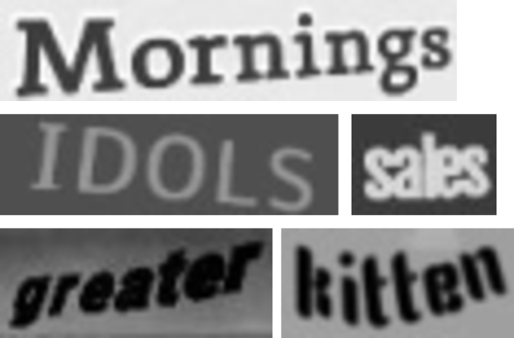

Figure :

SynthText (ST) is another synthetically generated dataset and was originally designed for scene text detection. An example of how the words are rendere donto scene images is shown in Figure. Even though SynthText was designed for scene text detection task,it has been also used for STR by cropping word boxes. SynthText has 5.5 M training data once the word boxes are cropped and filtered for non-alphanumeric characters.

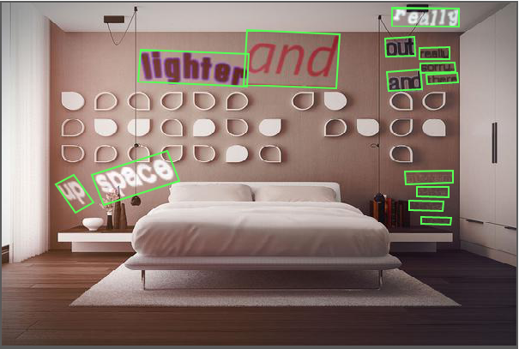

**Real-world datasets for evaluation**

**IIIT 5K-word**

The IIIT 5K-word dataset is harvested from Google image search. Query words like billboards, signboard, house numbers, house name plates, movie posters were used to collect images. The dataset contains 5000 cropped word images from Scene Texts and born-digital images. The dataset is divided into train and test parts. This dataset can be used for large lexicon cropped word recognition. We also provide a lexicon of more than 0.5 million dictionary words with this dataset.

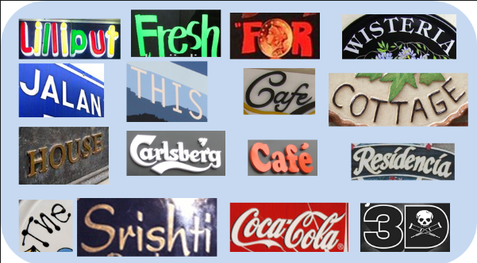

Figure:

With query words that are likely to return text images, such as “billboards”, “signboard”, “house numbers”, “house name plates”, and “movie posters”. IIIT consists of 2,000 images for training and 3,000 images for evaluation.

**Street View Text (SVT)**

Street View Text (SVT) contains outdoor street images collected from Google Street View. Some of these images are noisy, blurry, or of low-resolution. SVT consists of 257 images for training and 647 images for evaluation

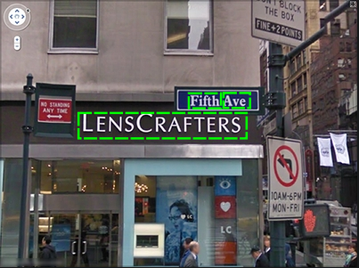

Figure :

The Street View Text (SVT) dataset was harvested from Google Street View. Image text in this data exhibits high variability and often has low resolution. In dealing with outdoor street level imagery, we note two characteristics. (1) Image text often comes from business signage and (2) business names are easily available through geographic business searches. These factors make the SVT set uniquely suited for word spotting in the wild: given a street view image, the goal is to identify words from nearby businesses. More details about the data set can be found in our paper, Word Spotting in the Wild. For our up-to-date benchmarks on this data, see our paper, End-to-end Scene Text Recognition. This dataset only has word-level annotations (no character bounding boxes) and should be used for (A) cropped lexicon-driven word recognition and (B) full image lexicon-driven word detection and recognition. If you need character training data then you should look into the Chars74K and ICDAR datasets .

**ICDAR2003**

ICDAR2003 was created for the ICDAR 2003 Robust Reading competition for reading cameracaptured scene texts. It contains 1,156 images for

training and 1,110 images for evaluation. Ignoring all words that are either too short (less than 3 characters) or ones that contain non-alphanumeric characters reduces 1,110 images to 867. However, researchers have used two different versions of the dataset for evaluation: versions with 860 and 867 images. The 860-image dataset is missing 7 word boxes compared to the 867 dataset. The omitted word boxes can be found in the supplementary materials.

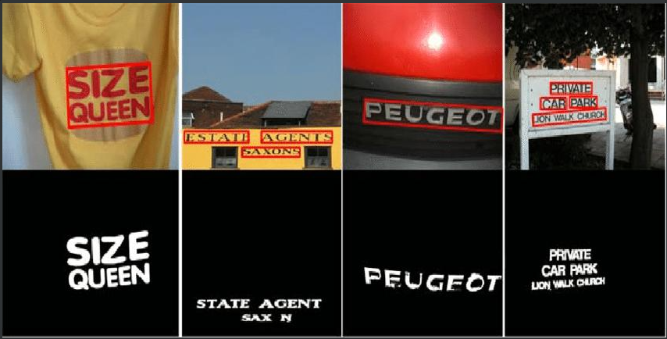

Figure :

Hence, the aims of ICDAR2003 are as follows:

• To capture and ground-truth a significant size text-inscene dataset. This should have a shelf-life well beyond that of the competitions.

• To design or adopt standard formats for these datasets, and also for the results produced by the recognizers.

• To design or adopt standard evaluation procedures according to current best practices.

• To run the competitions in order to get a snapshot of the current state of the art in this area.

**ICDAR2013**

ICDAR2013 (IC13) inherits most of IC03’s images and was also created for the ICDAR 2013 Robust Reading competition. It contains 848 images for training and 1,095 images for evaluation, where pruning words with non-alphanumeric characters results in 1,015 images. Again, researchers have used two different versions for evaluation: 857 and 1,015 images. The 857-image set is a subset of the 1,015 set where words shorter than 3 characters are pruned.

**SVT** **Perspective**

SVT Perspective (SP) is collected from Google Street View and contains 645 images for evaluation. Many of the images contain perspective projections due to the prevalence of non-frontal viewpoints

**CUTE80**

CUTE80 (CT) is collected from natural scenes and contains 288 cropped images for evaluation. Many of these are curved text images.

### **I.3.3. Training techniques**

The goal of the section is introducing the scene text recognition (STR) framework consisting of four stages, derived from commonalities among independently proposed STR models. After that, we describe the module options in each stage.

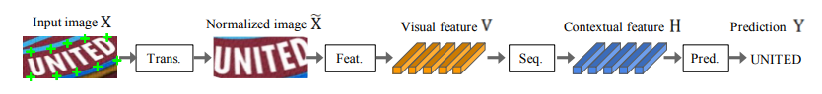

Figure :

**Transformation stage**

The module of this stage transforms the input image X into the normalized image X˜. Text images in natural scenes come in diverse shapes, as shown by curved and tilted texts. If such input images are fed unaltered, the subsequent feature extraction stage needs to learn an invariant representation with respect to such geometry. To reduce this burden, thin-plate spline (TPS) transformation, a variant of the spatial transformation network (STN), has been applied with its flexibility to diverse aspect ratios of text lines. TPS employs a smooth spline interpolation between a set of fiducial points. More precisely, TPS finds multiple fiducial points (green ’+’ marks in Figure 3) at he upper and bottom enveloping points, and normalizes the character region to a predefined rectangle. Our framework allows for the selection or de-selection of TPS.

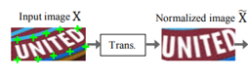

Figure :

**Feature extraction stage**

In this stage, a CNN abstract an input image (i.e., X or X˜) and outputs a visual feature map V = {vi}, i = 1, . . . , I (I is the number of columns in the feature map). Each column in the resulting feature map by a feature extractor has a corresponding distinguishable receptive field along the horizontal line of the input image. These features are used to estimate the character on each receptive field. We study three architectures of VGG , RCNN , and ResNet , previously used as feature extractors for STR. VGG in its original form consists of multiple convolutional layers followed by a few fully connected layers [26]. RCNN is a variant of CNN that can be applied recursively to adjust its receptive fields depending on the character shapes. ResNet is a CNN with residual connections that eases the training of relatively deeper CNNs.

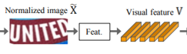

Figure :

**Sequence modeling stage**

The extracted features from Feat. stage are reshaped to be a sequence of features V . That is, each column in a feature map vi ∈ V is used as a frame of the sequence. However, this sequence may suffer the lack of contextual information.

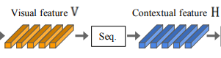

Figure :

Therefore, some previous works use Bidirectional LSTM (BiLSTM) to make a better sequence H = Seq.(V) after the feature extraction stage . On the other hand, Rosetta removed the BiLSTM to reduce computational complexity and memory consumption. **Prediction stage**

In this stage, from the input H, a module predict a sequence of characters, (i.e., Y = y1, y2, . . . ). By summingup previous works, we have two options for prediction:

(1) Connectionist temporal classification (CTC)

(2)attention-based sequence prediction (Attn).

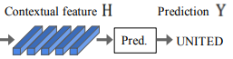

Figure :

CTC allows for the prediction of a non-fixed number of a sequence even though a fixed number of the features are given. The key methods for CTC are to predict a character at each column (hi ∈ H) and to modify the full character sequence into a non-fixed stream of characters by deleting repeated characters and blanks. On the other hand, Attn automatically captures the information flow within the input sequence to predict the output sequence. It enables an STR model to learn a character-level language model representing output class dependencies.framework allows for the selection or de-selection of BiLSTM.

# **Chapter III. Implement**

## **II.1. CRAFT**

### **II.1.1. Training CRAFT**

**II.1.1.1 Training**

The training set uses: SynthText with size 41gb including 858750 jpg images divided into 200 directories. Contains a total of 7,266,866 words, 28,971,487 characters.

Computer using ubuntu 20.04 configuration is i5-10400F, VGA Zotac 1060-6gb, Ram 16gb,SSD…

Other parameters: 400 epochs, each epoch has 500 interations with learning rate 0.5*10^-3, weight_decay=10^-1

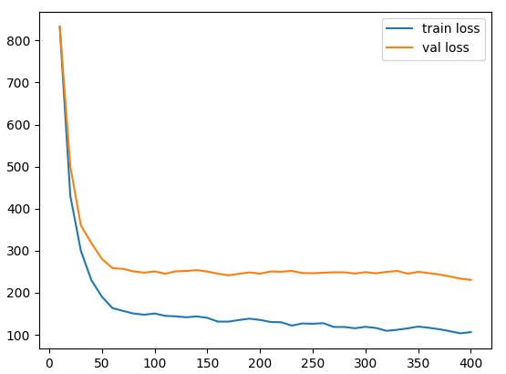

**Figure :**

**II.1.1.2 Firetune(Weak-Supervise)**

CTW1500, which includes over 10k text annotations in 1,500 images (1000 for training and 500 for testing). Based on this dataset, we pioneering propose a polygon based curve text detector (CTD) which can directly detect curve text without empirical combination. Moreover, by seamlessly integrating the recurrent transverse and longitudinal offset connection (TLOC), the proposed method can be end-to-end trainable to learn the inherent connection among the position offsets. This allows the CTD to explore context information instead of predicting points independently, resulting in more smooth and accurate detection. We also propose two simple but effective post-processing methods named non-polygon suppress (NPS) and polygonal non-maximum suppression (PNMS) to further improve the detection accuracy. Furthermore, the proposed approach in this paper is designed in an universal manner, which can also be trained with rectangular or quadrilateral bounding boxes without extra efforts. Experimental results on CTW-1500 demonstrate our method with only a light backbone can outperform state-of-the-art methods with a large margin. By evaluating only in the curve or non-curve subset, the CTD + TLOC can still achieve the best results.

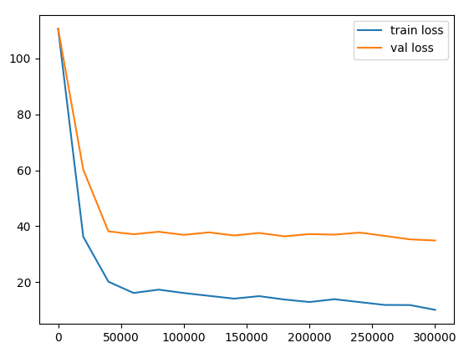

**Figure :**

**II.1.2. Evaluate CRAFT**

|  |  |  |  |
| --- | --- | --- | --- |
|  | **Precision** | **Recall** | **Hmean** |
| **ICDAR2013** | **97.4** | **93.1** | **95.2** |
| **My** | **91.7** | **92.21** | **91.95** |
| **ICDAR2015** | **89.8** | **84.3** | **86.9** |
| **My** | **84.51** | **79.71** | **81.80** |

### **II.1.3 Testing CRAFT**

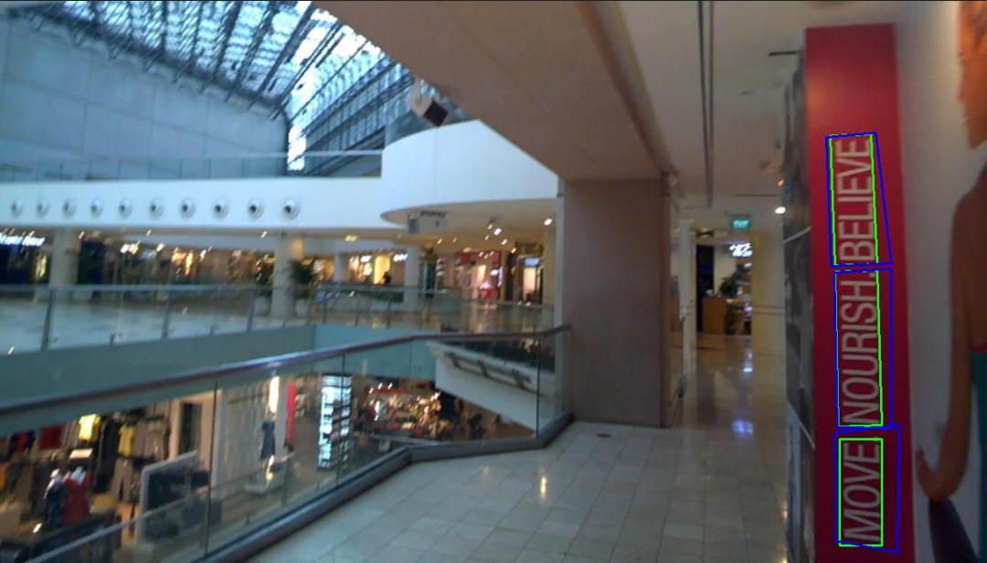

**figure**

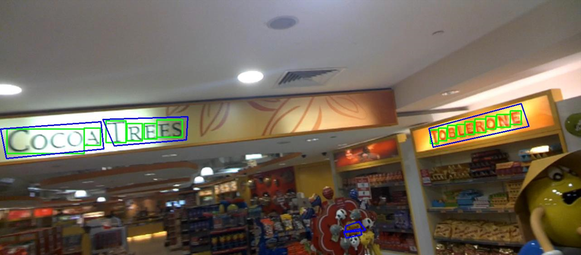

**Figure**

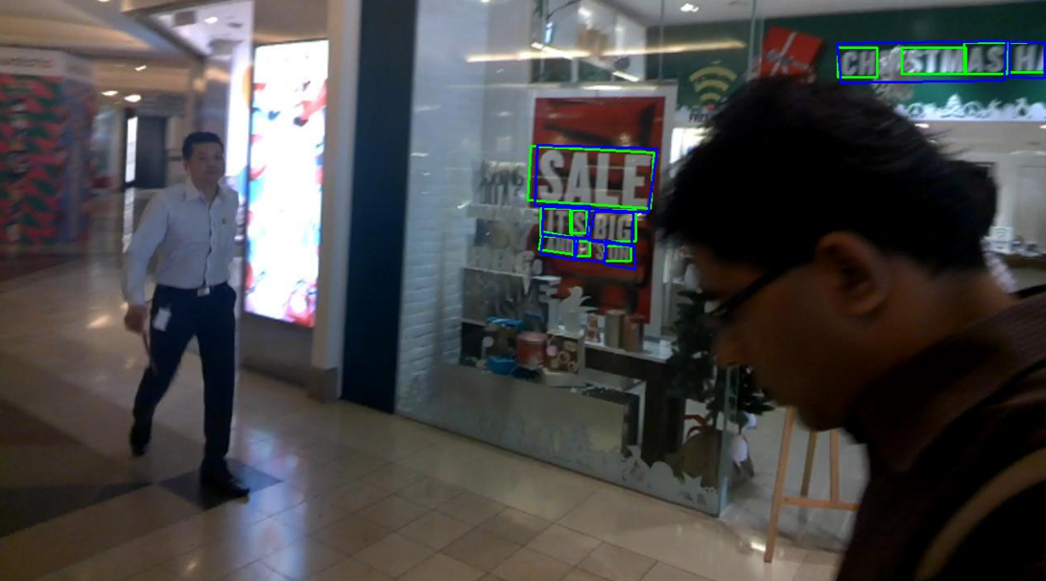

**Figure :**

## **II.2. 4-Stage Network**

### **II.2.1. Training 4-Stage Network**

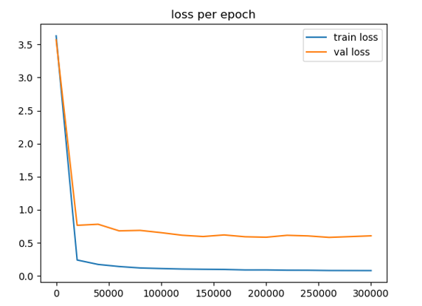

**Figure :**

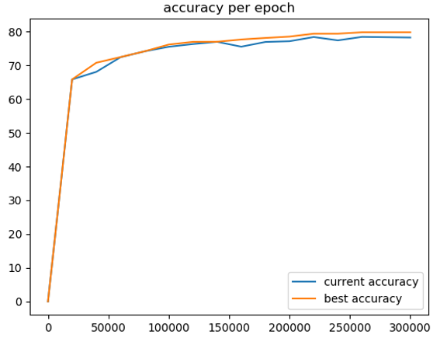

**Figure :**

### **II.2.2. Evaluate 4-Stage Network**

|  |  |  |  |  |  |  |  |  |  |  |
| --- | --- | --- | --- | --- | --- | --- | --- | --- | --- | --- |
| **Dataset** | **IIIT** | **SVT** | **IC03** | | **IC13** | | **IC15** | | **SP** | **CT** |
| **Sample** | 3000 | 647 | 860 | 867 | 857 | 1015 | 1181 | 2077 | 645 | 288 |
| **My** | 85.6 | 86.5 | 93.4 | 92.9 | 92.6 | 90.2 | 74.6 | **71.9** | 76.7 | 71.4 |
| **Paper** | **87.9** | **87.5** | **94.9** | **94.4** | **93.6** | **92.3** | **77.6** | 71.8 | **79.2** | **74.0** |

**Table :**

### **II.2.3. Testing 4-Stage Network**

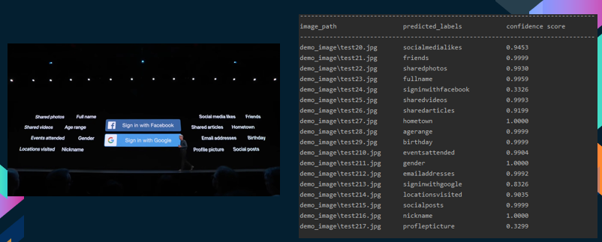

**Figure :**

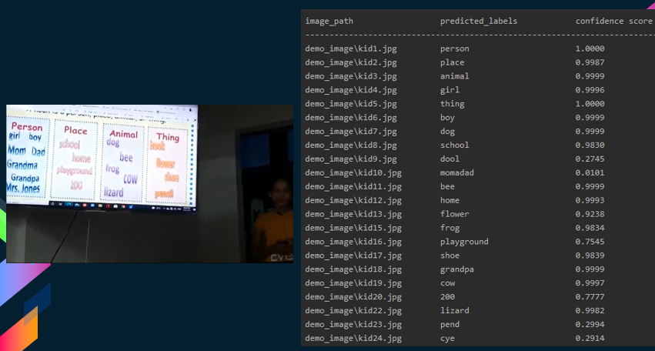

**Figure :**

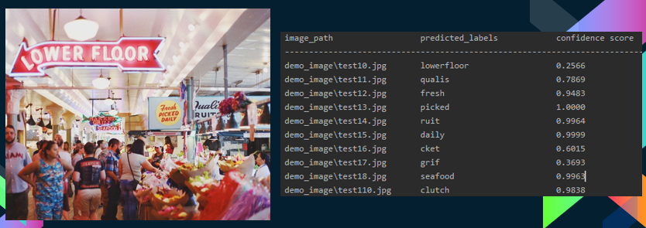

**Figure :**

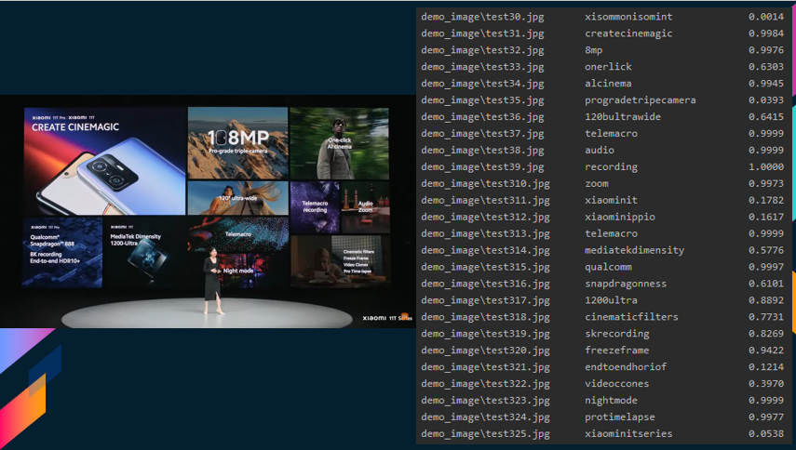

**Figure :**

# Chapter IV : Web design

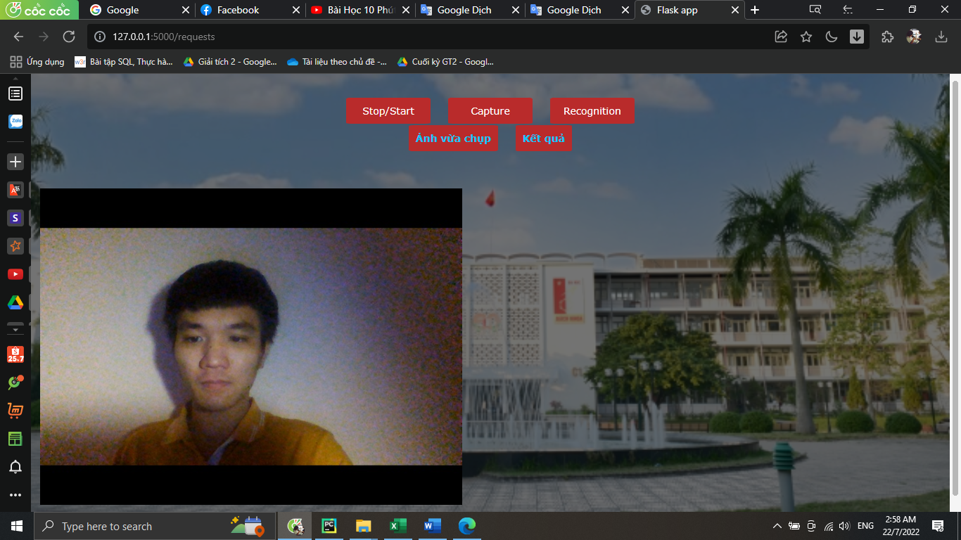

Figure :

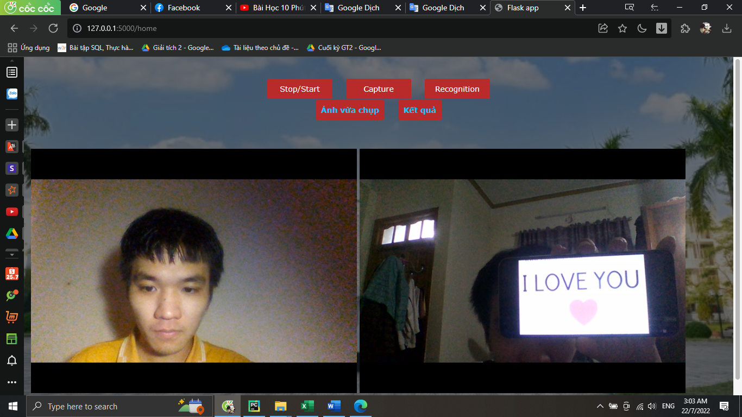

Figure

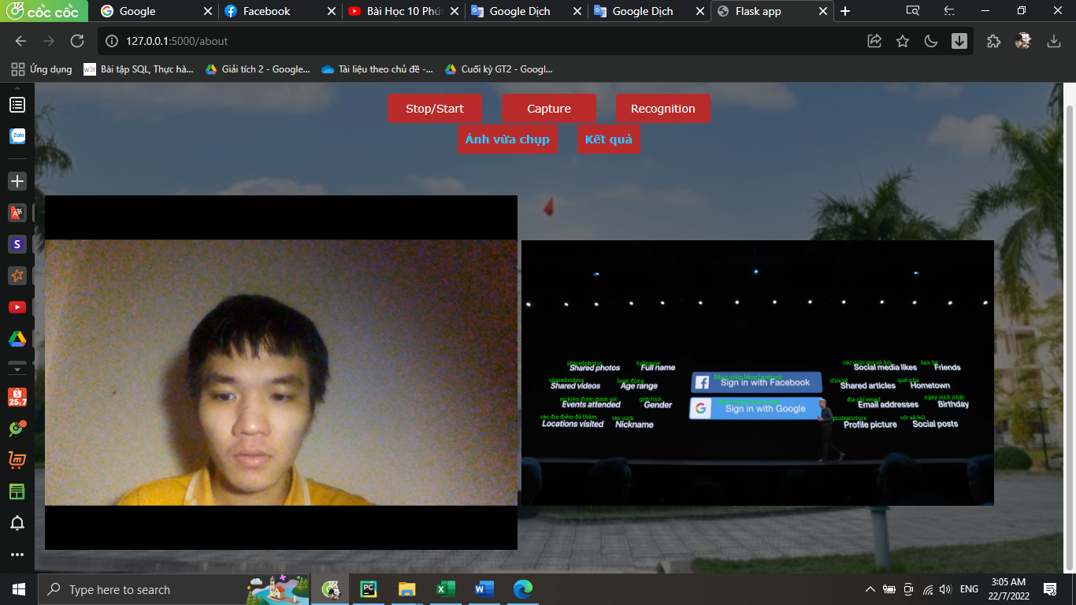

# **Conclusion**

Tóm gọn nội dung phần kết luận trong khoảng một trang in A4. Nội dung phần kết luận này tùy thuộc vào từng đồ án. Lưu ý trong phần kết luận không nên có bất cứ phương trình, biểu đồ hay bảng biểu nào. Cần trình bày rõ nội dung đồ án môn học đã đáp ứng đầy đủ các yêu cầu của đề bài hay chưa. Trình bày về ý nghĩa của các kết quả thu được, các đánh giá nhận xét về tính khả thi, tính chính xác của kết quả, tính thực tế của đồ án… Cần lưu ý hạn chế sử dụng các tính từ, trạng từ mạnh trong khi miêu tả kết quả đạt được, cần đảm bảo tính trung thực của các kết luận.

Trình bày các kiến thức mà sinh viên đã đạt được sau khi thực hiện đồ án môn học. Đồng thời trình bày về các kỹ năng đã học được (kỹ năng tự tìm kiếm tài liệu, tổng hợp thông tin, kỹ năng chế bản, kỹ năng trình bày, viết báo…).

# **Future Work**

With the results achieved, the next development direction of the project will be:

Optimizing the current algorithm and applying some advanced machine learning algorithms

# **References**

|  |  |
| --- | --- |
|  | * 1. *Risnumawan A, Shivakumara P, Chan C S, et al. A robust arbitrary text detection system for natural scene images[J]. Expert Systems with Applications, 2014, 41(18):8027-8048.*   2. *Lucas S M, Panaretos A, Sosa L, et al. ICDAR 2003 Robust Reading Competitions[M]. IEEE Computer Society, 2003.*   3. *Karatzas D, Shafait F, Uchida S, et al. ICDAR 2013 Robust Reading Competition[C]// International Conference on Document Analysis and Recognition. IEEE, 2013:1484-1493.*   4. *Karatzas D, Gomez-Bigorda L, Nicolaou A, et al. ICDAR 2015 competition on Robust Reading[C]// International Conference on Document Analysis and Recognition. IEEE Computer Society, 2015:1156-1160.*   5. *Mishra A, Alahari K, Jawahar C V. Scene Text Recognition using Higher Order Language Priors[C]// 2012.*   6. *Wang K, Babenko B, Belongie S. End-to-end scene text recognition[C]// IEEE International Conference on Computer Vision. IEEE, 2012:1457-1464.*   7. *Phan T Q, Shivakumara P, Tian S, et al. Recognizing Text with Perspective Distortion in Natural Scenes[C]// IEEE International Conference on Computer Vision. IEEE, 2014:569-576.* |